**Travel Guide**

**Contents:**

1. Design
2. Architecture Diagram
3. Class Diagram
4. Implementation
5. Web Services/Existing APIs
6. Database
7. Mobile User Interface
8. Screen Shots
9. Web Services and Site URLs
10. Github URL
11. Limitations
12. References

**DESIGN:**

The Design stage shows the overall idea of the application that is implemented.

The primary focus of the application is making a plan for the trip. That saves the time by having the knowledge of distance that is associated between source and destination.

1. The below Diagram Shows the Class diagram that is associated with the implementation.
2. The below Diagram shows the Architecture Diagram of the application.

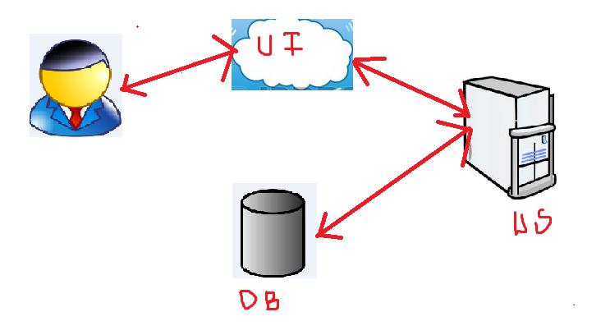

**IMPLEMENTATION**

1. Existing API is used in this application development.

Google API is used in this implementation.

The URL is:

<http://maps.googleapis.com/maps/api/distancematrix/json?origins=%22uppal%22&destinations=%22kukatpally%22&mode=driving&language=fr-FR&sensor=false>.

1. Database
2. Mobile User Interface Is developed that can be accessed through any mobile device with the reference url.

**SCREEN SHOTS**

This is the main page for the application that redirects to other pages such as HOME, SignIn, Sign Up.

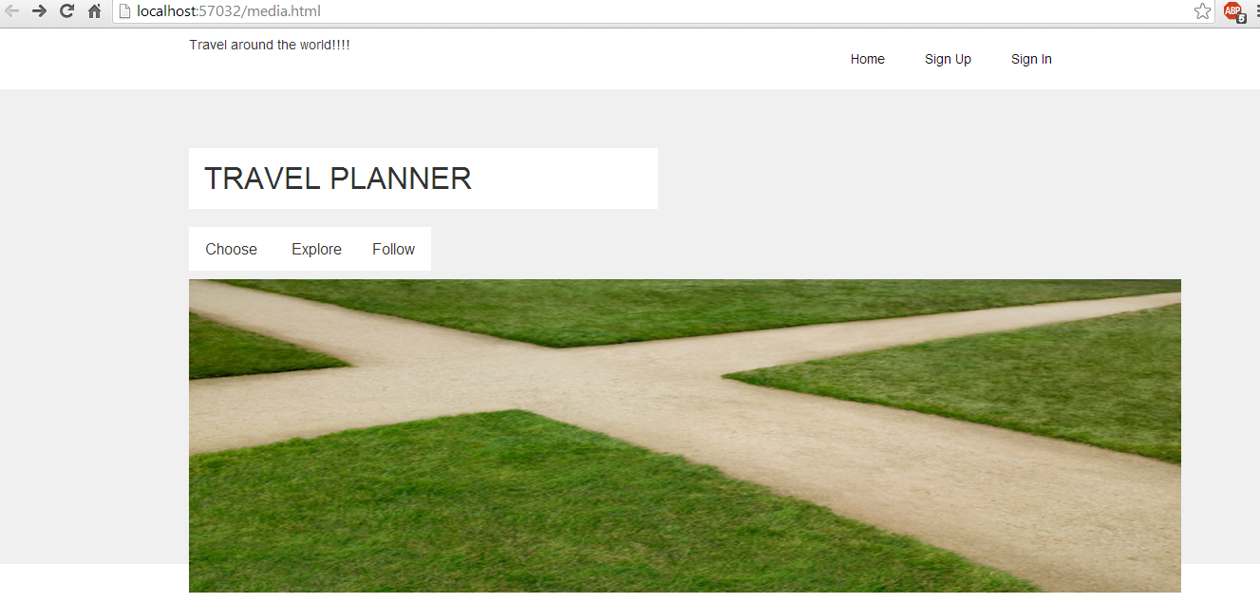

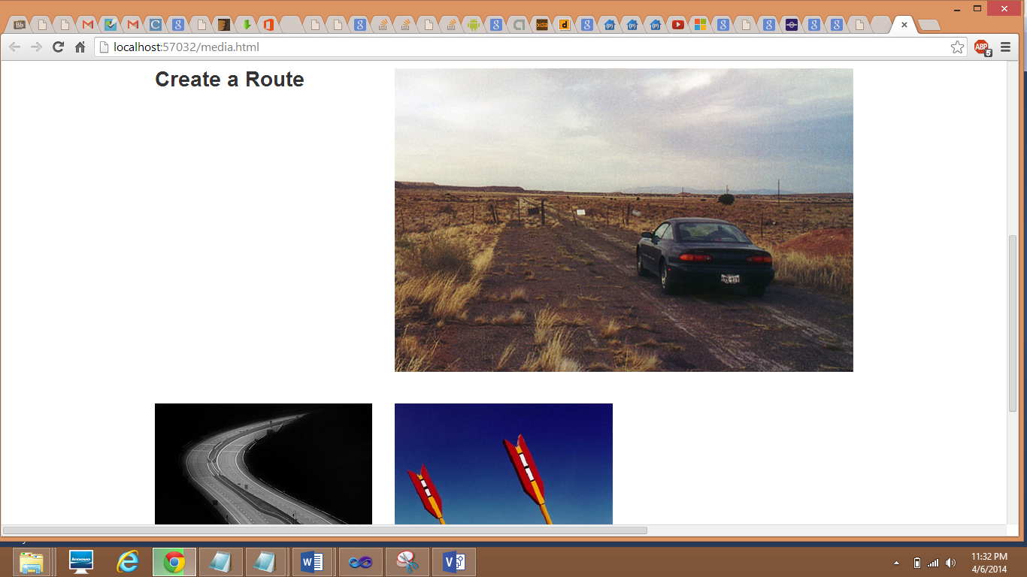

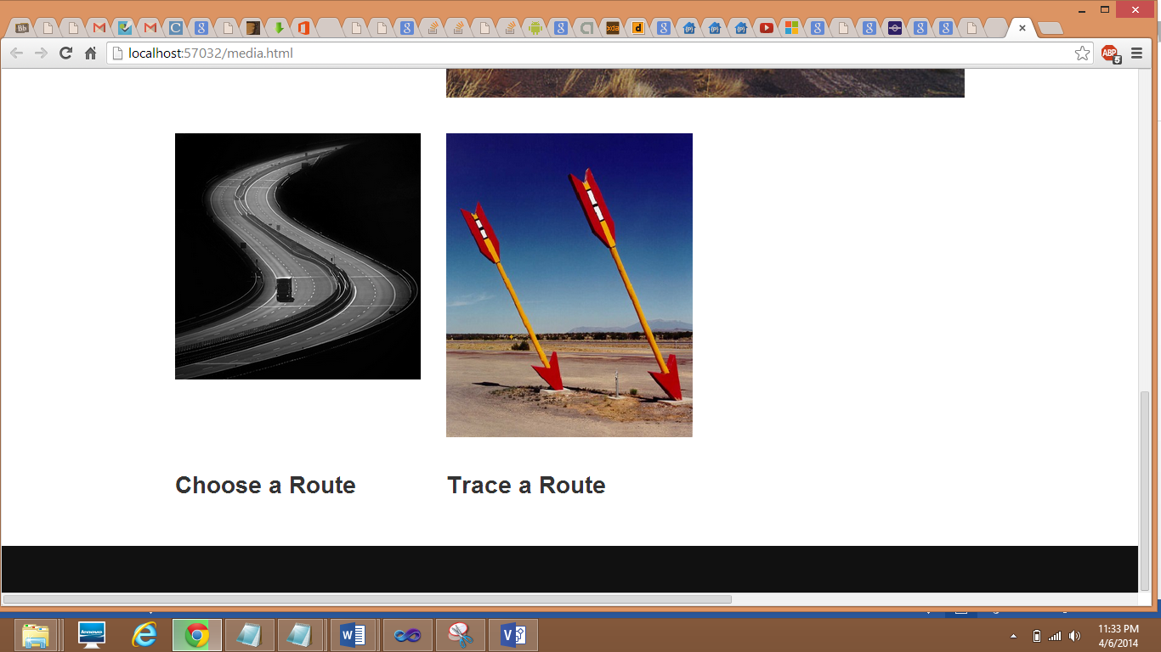

New users registers for an account.

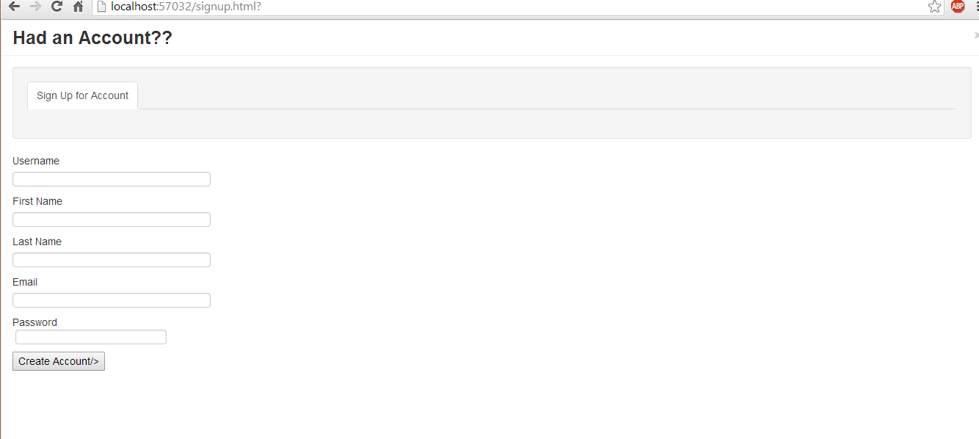

Already registered users uses their login credentials to signIn

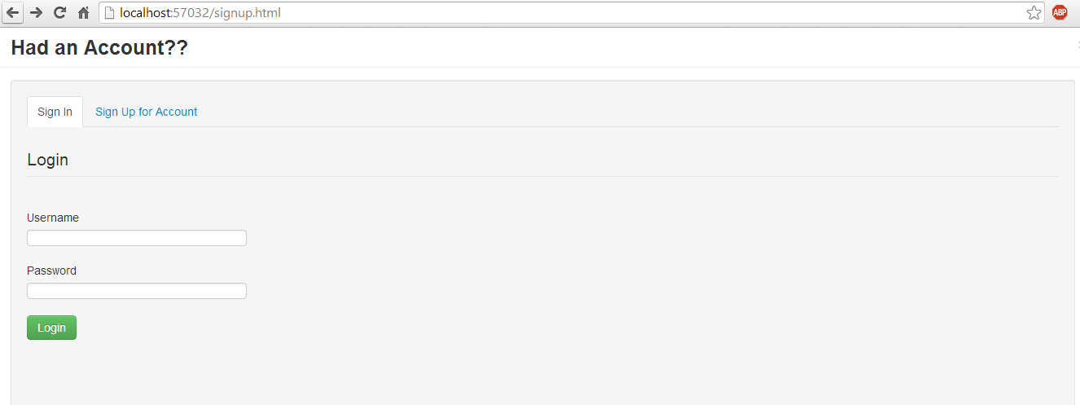

The Home page is designed as following

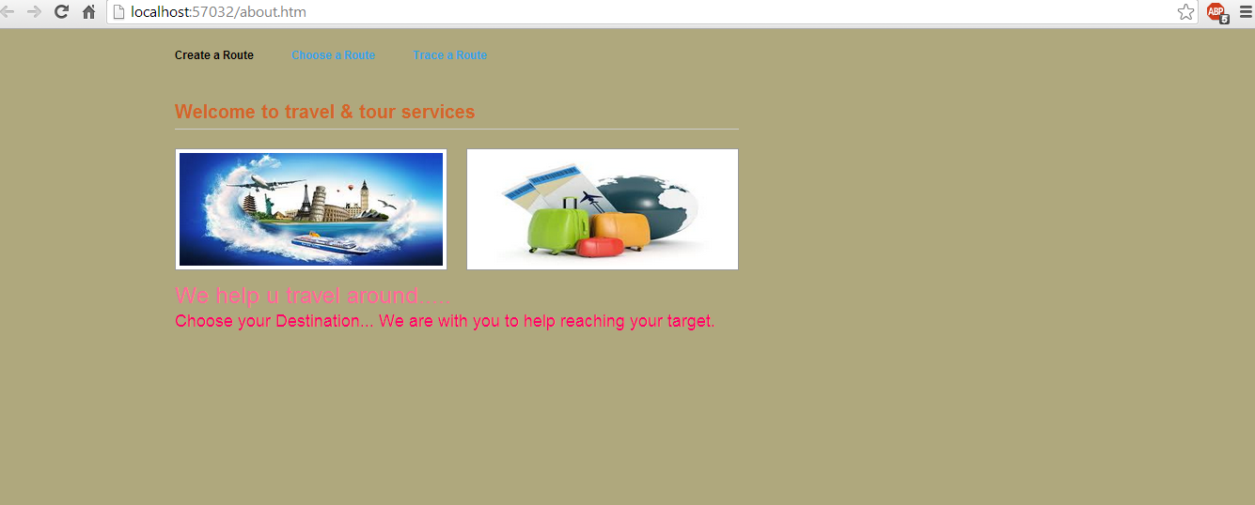

The page is navigated when the choose route is selected

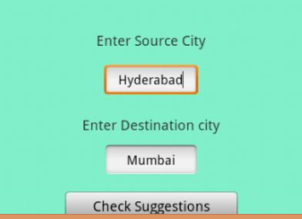

The Distance is shown when the origin and destination are submitted.

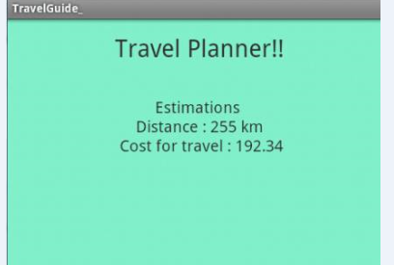

WesiteURLs

1. <http://startbootstrap.com/full-slider>
2. “googleimages”
3. <http://maps.googleapis.com/maps/api/distancematrix/json?origins=%22uppal%22&destinations=%22kukatpally%22&mode=driving&language=fr-FR&sensor=false>.

**Limitations**

The application needs some improvements to be done and Extensions are required such as marking the route that is travelled.

**References**

1. <http://startbootstrap.com/full-slider>
2. “googleimages”
3. <http://maps.googleapis.com/maps/api/distancematrix/json?origins=%22uppal%22&destinations=%22kukatpally%22&mode=driving&language=fr-FR&sensor=false>.